LONGHOUGHTON PARISH

county councillor report

County Councillor wendy pattison
wendy.pattison@northumberland.gov.uk – Tel. 07779 983072 and also on Facebook
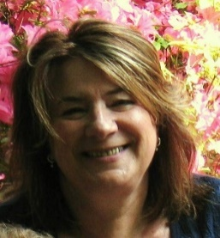
Longhoughton Parish

community: staying positive during the coronavirus crisis
These anxious and unusual times bring unforeseen difficulties. But the best of human nature can rise to the challenge.
As County Councillor, I feel extremely proud of all of our Parish/Village Communities which lie within the Longhoughton Ward. From Newton by the Sea all the way across country to Powburn near Wooler taking in some of the most beautiful scenery in Northumberland, the Longhoughton Ward communities are pulling together and trying to help those who are self-isolating with supportive telephone calls, picking up medication and shopping. Our small local businesses are also playing a major role in delivering what they can to resident’s doorsteps and in many cases they have a variety of stock which is not always available in large supermarkets.
For those who are not aware, (and with profuse apologies if I have missed a village/hamlet out) the Longhoughton Ward covers all of the following 9 Parishes and the villages/hamlets which lie within those parishes;
Longhoughton, Boulmer, Howick, Embleton, Christon Bank, Dunstan Steads, Newton by the Sea, Falloden, Brunton, Doxford, Ellingham, Chathill, Tyneley, Wandylaw, Brownieside, Newham, Craster, Dunstan, Rennington, Stamford, Rock, Eglingham, North Charlton, South Charlton, Edlingham, Hedgeley, Powburn, Bolton, Beanley, Titlington.
From Whats App to Next Door Social media groups our communities are in touch and if anyone has any questions/queries/concerns please contact me as below.
Tel. 01665 579137 – 07979067321 – 07779983072

Council’s trading standards investigate inflated pricing
Northumberland Trading Standards team have been investigating highly inflated and misleading pricing of toiletries and similar products as a result of the Covid-19 outbreak, and are asking residents to be aware and report any unethical pricing.
Complaints have been received by the service that traders have been selling goods that are already price marked on the packaging, at a much higher price than that displayed.
The Consumer Protection from Unfair Regulations 2008 and Guidance for Traders on pricing states that traders ‘need to behave professionally and responsibly in the pricing of their products’.They are expected to formulate pricing in accordance with honest market practice and pricing must not be misleading or false.
Northumberland County Councillor John Riddle, Cabinet Member with responsibility for public protection said: “While the vast majority of retailers have been working incredibly hard to support local residents, we have had reports that some of our residents including vulnerable people are being asked to pay greatly inflated prices for what are standard products.
“It’s extremely frustrating that customers are reporting that some local businesses are overcharging for goods that are in high demand. We are in an unforeseen and unprecedented national emergency, and this level of profiteering is unethical and really lacks the community spirit that has been displayed across our communities.
“Our officers are contacting these businesses and advising them of the law.”
If residents have concerns about the selling price of goods then they should contact trading standards by email tradingstandards@northumberland.gov.uk
Business are advised to contact Trading Standards if they require advice about price marking of goods by emailing tradingstandards@northumberland.gov.uk - leaving their telephone number so a member of the team can ring them back.

Car parks closed as people urged to stay at home
Car parks at some of the most beautiful tourism destinations along the Northumberland coast have had to be closed following the Government’s latest guidance on all non-essential travel and clear instruction that people should stay at home.
This has been another difficult decision from the County Council but it comes after a small minority ignored the Government’s national ‘stay at home’ advice and continued to visit some areas in numbers this week.
The the car parks that will close include:
Spittal, Berwick upon Tweed
Bamburgh
Holy Island
Seahouses
Craster
Beadnell
Newton Steads
Low Newton
Warkworth Beach Picnic Site
Amble Braid
Cresswell Dunes
Blyth Mermaid, Beachway and Ranch car parks
Fountain Head and Old Hartley car parks, Seaton Sluice
The council’s three main country parks which attract large numbers of tourists - Bolam Lake, Plessey Woods and Druridge Bay, along with the car parks at these sites, are also now closed, until further notice.
Urban country parks, parks and green spaces will remain open to enable local residents to exercise, but playgrounds will be closed, and all residents should strictly follow Government guidance on social distancing and gatherings. This will be kept under review and may be subject to further change, if required.
All public toilets in the county will also be closed until further notice.
Council Leader Peter Jackson said: “While our beautiful environment and our country parks are some of the jewels in the crown of our great county it is important for us to take these steps in line with Government guidance on non-essential travel as a means of persuading people to stay at home.
“The Government guidance is very clear - people should stay at home and avoid social contact to protect the NHS and save lives - and it’s disappointing a small minority aren’t taking this seriously enough.
“Over recent days a number of our country parks and tourist car parks were still very busy so we’ve had to take action. It is imperative every single one of us heeds the Government’s messages on not going out unless strictly necessary. Following this guidance will help save many lives.”

Stay at home: guidance for households with possible coronavirus (COVID-19) infection

Symptoms
The most common symptoms of coronavirus (COVID-19) are recent onset of:
- new continuous cough and/or
- high temperature
For most people, coronavirus (COVID-19) will be a mild illness.
Main messages
- if you live alone and you have symptoms of coronavirus illness (COVID-19), however mild, stay at home for 7 days from when your symptoms started. if you live with others and you are the first in the household to have symptoms of coronavirus, then you must stay at home for 7 days, but all other household members who remain well must stay at home and not leave the house for 14 days. The 14-day period starts from the day when the first person in the house became ill.
- for anyone else in the household who starts displaying symptoms, they need to stay at home for 7 days from when the symptoms appeared, regardless of what day they are on in the original 14 day isolation period.
- it is likely that people living within a household will infect each other or be infected already. Staying at home for 14 days will greatly reduce the overall amount of infection the household could pass on to others in the community
- if you can, move any vulnerable individuals (such as the elderly and those with underlying health conditions) out of your home, to stay with friends or family for the duration of the home isolation period
- if you cannot move vulnerable people out of your home, stay away from them as much as possible
- if you have coronavirus symptoms:
  - do not go to a GP surgery, pharmacy or hospital
  - you do not need to contact 111 to tell them you’re staying at home
  - testing for coronavirus is not needed if you’re staying at home
- plan ahead and ask others for help to ensure that you can successfully stay at home and consider what can be done for vulnerable people in the household
- ask your employer, friends and family to help you to get the things you need to stay at home
- wash your hands regularly for 20 seconds, each time using soap and water, or use hand sanitiser
- if you feel you cannot cope with your symptoms at home, or your condition gets worse, or your symptoms do not get better after 7 days, then use the NHS 111 online coronavirus service. If you do not have internet access, call NHS 111. For a medical emergency dial 999

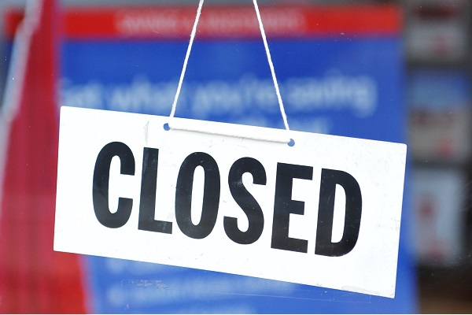

Public access to NCC buildings from 23 March 2020
Following the Government’s advice in relation to further measures regarding social distancing, it’s important we protect both our residents and our staff. The council is now planning to restrict public access to our buildings from 12noon, Monday 23 March 2020.
We will now be moving our libraries service to a fully digital and online offer, with requests for books to be facilitated via community groups wherever possible, including assisting our most vulnerable residents e.g. large print requests etc. Libraries will also move to provide a telephone befriending service, including doorstep deliveries which our community fleet will assist with. We are also preparing further digital and online content, and supporting and helping to coordinate any community offering that is needed through a volunteer programme which we will announce details about over the coming days.
Customers can find a range of audio, ebooks and magazines via the BorrowBox and RB Digital apps, which can be downloaded from the library website - www.mylibrary.co.uk
Customer Service, Information Centres and Registrars will move to a first point of contact being a digital recommendation. We will not have any front of house staffing and facilities, and will only offer a limited face to face service available at our sites if it is safely managed, by appointment only and after a risk assessment deems it necessary to do so.
The safest way for you to contact the council is via our website at www.northumberland.gov.uk/contact - You can also call us on 0345 600 6400 during office hours.
We now have dedicated #CoronaVirus section on our website dedicated to provide you with the information and updates on our services at www.northumberland.gov.uk/coronavirus

Residents reminded to heed social distancing advice - 23 March 2020
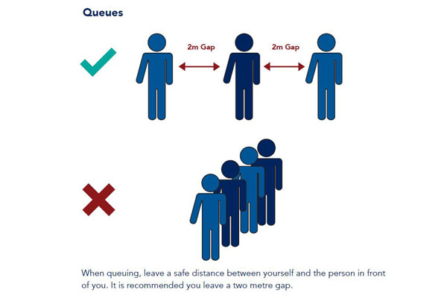
Northumberland residents are being reminded that they must heed social distancing advice as the country tackles the coronavirus pandemic.
The weekend saw a number of towns and coastal hotspots busy with locals and visitors, despite national and local advice for people to keep a safe distance from each other and avoid gathering in even small numbers.
Liz Morgan, the Council’s Director of Public Health, said: “We continue to work tirelessly to respond, prepare and deal with COVID-19 - prioritising the key services which are vital to our communities.
“However, we are approaching a critical phase and Northumberland and the north east cannot avoid the very real consequences of this disease.
“While we live in a beautiful county famous for the great outdoors we need to protect ourselves, our families and loved ones, our key workers and our communities and to do that we must act now. Every single one of us must take responsibility to reduce to a minimum the number of daily social contacts we have; the actions we take over the next days and weeks will determine the extent to which we prevent lives from being lost.”
Professor Peter Kelly, PHE North East Centre Director added: “Those who can work from home should do so. Those who work in essential services and need to go to their workplace should rigorously pay attention to social distancing in that workplace. Avoid non-essential use of public transport.
“We should only go shopping for essential items such as food and medicines and if we do, then we must take great care to keep a safe distance (2 metres) from other people. I know following this guidance is hard. But we must avoid gathering with our wider family and friends where possible and avoid large and small gatherings in public spaces. If we need fresh air and exercise then we must stay close to home and avoid other people.
“Finally, as the Easter break approaches and the weather improves, our natural instinct is to think of the many wonderful assets and beauty spots we have across the North East. I would say in the strongest possible terms we are living in exceptional times and we all need to make very real adjustments and sacrifices to protect ourselves and others. Stay at home, do not travel other than for necessary work or essentials and please follow the guidance here to stay safe: Social distancing to protect vulnerable groups“
I will keep sending out my monthly reports, stay safe and hopefully see you all very soon. Wendy

